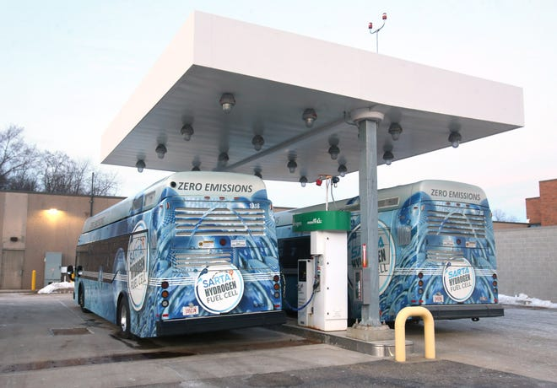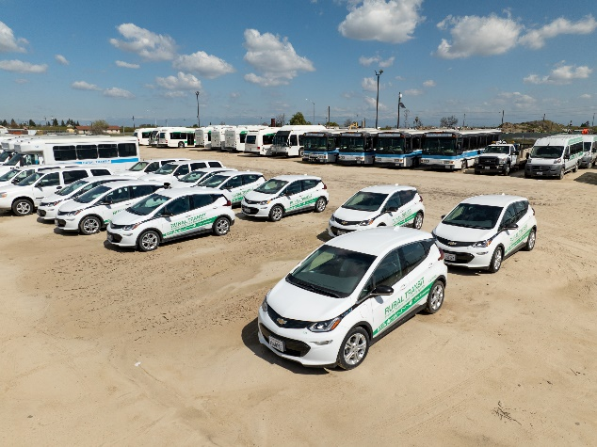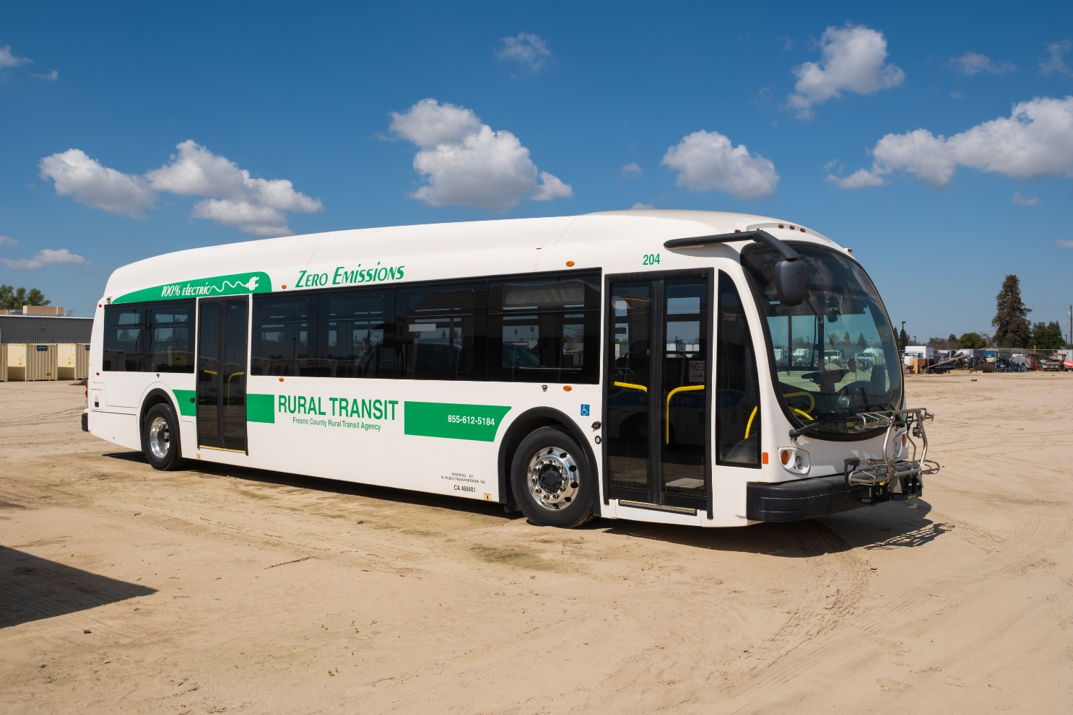

FCRTA/Caltrans Zero Emission Fleet Transition Plan Project

DRAFT Summary Report

January 11, 2025

# Caltrans Corridor System Management Plan (CSMP) - Solano ...

*Source: Stark Area Regional Transit Authority*

# Summary of Work Performed – Caltrans Zero Emission Vehicle (ZEV) Transition Plan Grant (2024)

This year-long grant effort was designed to provide technical assistance to transit agencies in preparing their Fleet Transition Plans, as required by FTA for the 5339 (b) and (c) grants. Overall, the grant work focused on:

* **Outreach**: Outreach to transit agencies to educate them on the requirements of the FTA Fleet Transition Plans.
* **Technical Resources**: Preparation of technical resources guiding agencies in preparing their Fleet Transition Plans, focused on helping agencies adapt their CARB ICT plans to meet the FTA requirements.
* **Drafting Agency Transition Plans**: The project team prepared draft FTA Fleet Transition Plans for transit agencies. The team also assisted Santa Cruz Metro in updating its CARB ICT plan to reflect its current planning for zero-emissions vehicles. The agency was recently awarded a grant for 53 fuel-cell electric buses, resulting in a need to update its current CARB plan.

This document summarizes the work performed. Fresno County Rural Transit Agency (FCRTA) was the grant recipient, who hired Walker Consultants (Walker) to lead the work.

## Outreach

### Project Website and Promotional Materials

The project team created a website devoted to technical assistance with the ZEV Transition Plan. Website link: [Zero-Emissions Fleet Plans for CA Transit Agencies - Walker Consultants](https://walkerconsultants.com/blog/2024/04/10/zero-emissions-fleet-plans-for-ca-transit-agencies/)

The website provided an overview of the project, technical resources and project team contact information. (screenshots of the website are shown below)

The Project Team created business cards and a poster to include at outreach events, as shown below.

The project team developed an e-mail address exclusively for the project to allow transit agencies to contact the entire project team. [**zeroemissions@walkerconsultants.com**](mailto:zeroemissions@walkerconsultants.com)

### Direct Outreach

* Contacted over 100 transit agencies via e-mail directly to provide information on the technical resources offered, including a link to the website and outreach to all FTA 5311 recipients.
* Contacted all 49 CalCOG member agencies.

A list of agencies we reached out directly to is included in Attachment 1.

### Newsletters

The project team included information about the technical assistance offered by publishing in professional organization newsletters, including:

* The Clean Mobility Options (CMO) Clean Mobility Equity Alliance (CMEA) July 2024, see link for newsletter: [Your July CMEA Newsletter](https://mailchi.mp/838cf55d7873/your-november-cmea-newsletter-17841460)
* California Association of Councils of Governments (CALCOG) June 2024: See the link for the newsletter: [Planning and Programming Notes!](https://mailchi.mp/calcog.org/planning-and-programming-notes?e=eff20fe834)

### Conferences and Training

The project team attended and presented at conferences to reach local governments and transit agencies about the technical services available. Below is a list of conference events (Task Order included four conferences):

* California Association for Coordinated Transportation (CALACT) Spring Conference, San Diego, CA (4/16/2024-4/18/2024) – hosted an event booth and gave a training presentation.
* California Association for Coordinated Transportation (CALACT) North State Transit Symposium, Ukiah, CA (7/10/2024-7/11/2024) – hosted an event booth.
* Central Valley Transit Managers Meeting (8/14/2024) – gave a training presentation to CVTM members.
* California Association for Coordinated Transportation (CALACT) Maintenance Conference, Clovis, CA (10/14/2024-10/15/2024)— shared the presentation with conference attendees.
* Clean Mobility Equity Alliance (CMEA) Monthly Meeting (November 12, 2024) – gave presentation to CMEA members.

The project team created the following banner for when the project team hosted conference booths.

A copy of the conference presentations is included in Attachment 2.

We conducted online training with transit agencies individually regarding the FTA requirements and the technical resources available with a total of 22 transit agencies (task order included a minimum of three trainings). This training included guidance on requirements, discussion of their fleet transition plans and needs, and review and evaluation of their transition plans to comply with FTA. Agencies provided training for included:

* MOVE Stanislaus
* Kern County
* Dignity Health Connected Living
* Calaveras Council of Governments
* City of Calabasas
* City of San Luis Obispo
* Santa Cruz Metro
* Monterey-Salinas Transit District
* Turlock Transit
* Redding Area Bus Authority
* City of Glendora
* California City
* City of Escalon
* City of Ripon
* Imperial County Transportation Commission (ICTC)
* Yurok Tribe
* Lake Transit Authority
* Council of San Benito County of Governments
* City of Manteca
* City of Porterville
* City of Tracy
* Fresno Economics Opportunities Commission (EOC)

## Technical Resources

Fresno County Rural Transit Agency, in partnership with Walker Consultants, produced the following technical resources:

* FTA Zero-Emission Fleet Transition Plan Guide (Attachment 3)
* FTA Zero-Emission Fleet Transition Plan Template (Attachment 4)
* ZEV Funding Sources Matrix (Attachment 5)
* Zero Emissions Bus Technology Fact Sheet and Best Practices Guide (Attachment 6)

## Drafting Agency Transition Plans

The project team drafted FTA-required transition plans for the following transit agencies for a total of 15 plans (task order included a minimum of 8 plans) (Attachment 7)

* Kings County
* MOVE Stanislaus
* Kern County
* Calaveras Council of Governments
* Turlock Transit
* Redding Area Bus Authority
* City of Glendora
* City of Escalon
* City of Ripon
* Imperial County Transportation Commission
* Yurok Tribe
* Lake Transit Authority
* Council of San Benito County of Governments
* City of Manteca
* City of Tracy

### Santa Cruz Metro CARB ICT Plan Update

The project team assisted Santa Cruz Metro in updating its CARB ICT plan to reflect its current planning for zero-emissions vehicles. The agency was recently awarded a grant for the purchase of 53 fuel-cell electric buses, resulting in a need to update its current CARB plan. The project team drafted an update to Santa Cruz Metro’s plan based on current information and created an Excel template allowing the agency to update its fleet tables and charts as they continue policy discussions on their transition planning. The updated draft plan and Excel template are included in Attachment 8.